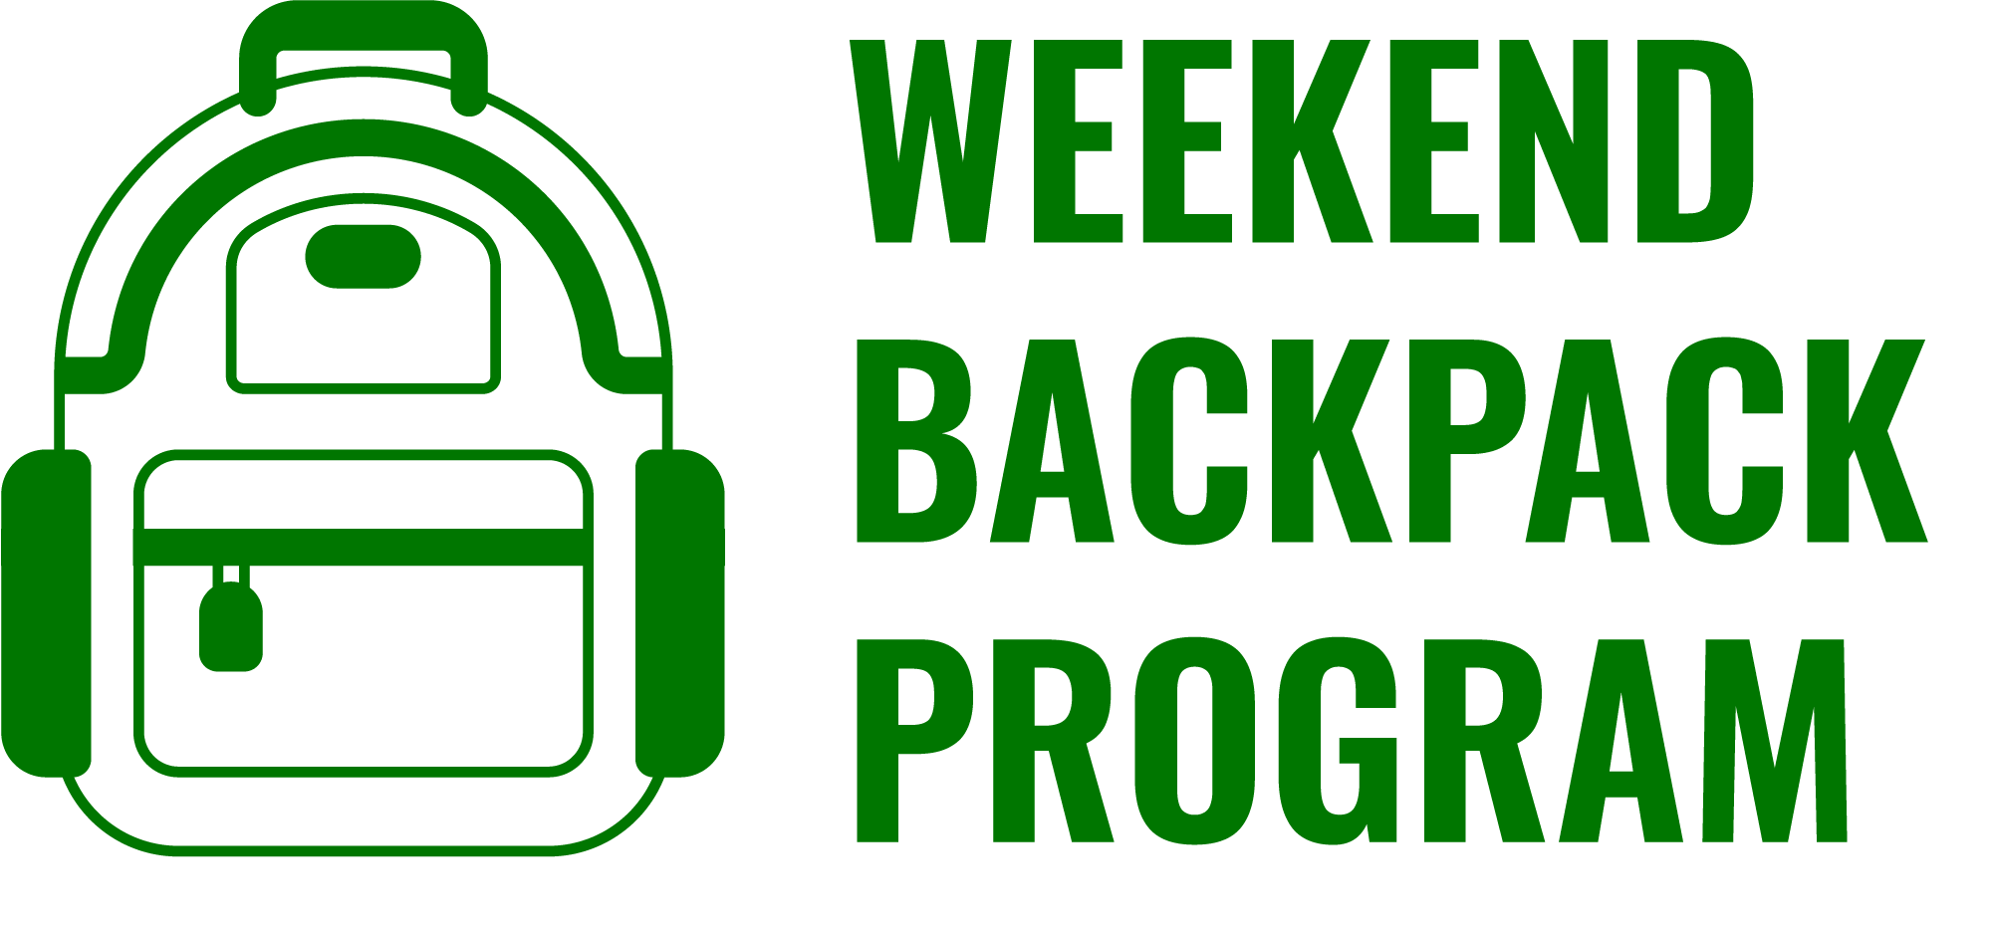

FREE Weekend Food for Your Child/Children Available!

The Name of School participates in the Weekend Backpack Program to offer a supply of nutritious
meals and snacks for children over the weekend, free of charge if you are struggling to meet your
family’s food needs and would benefit from receiving additional food.The staff will discreetly
distribute weekend bags on the last school day before the weekend. Any child enrolled at the Name
of School is able to receive these weekly bags of food. The program will begin on Start Date. If your
family is enrolled, your child/children will receive a bag of food each week until the end of the
school year or until you no longer wish to participate.

If you feel that your children would benefit from receiving additional food to meet their nutritional
needs over the weekend, we encourage you to sign them up by filling the form out below and
returning it to the front office. Enrollment is ongoing, however, the sooner your form is returned the
sooner we can start sending food home. Please send this form back to School/Program Contact by
date if you are interested! Only one form is needed for all the children in your family, but include
information for each child in the form below. If you have a child or children who attend other
City/Town Public Schools, please include that information below. This information will be kept
confidential between you and the staff at the Name of School. Questions or concerns? Please
contact name, email, number of School/Program Contact.

Weekend Backpack Program Consent Form
Please sign my child/children up for the Weekend Food program! I understand my child/children will soon start receiving a bag of food at the end of each week to help feed him/her over the weekend.
PLEASE PRINT CLEARLY.
Child’s Name | Age | School and Grade  (if applicable) | Special Dietary Needs  (None, Kosher, Halal, Vegetarian, Nut Free)

Parent/Guardian Name_________________________________________________________________
Telephone Number (if any) ______________________________________________________________
Parent/Guardian Email Address (if any) ____________________________________________________
Are you currently living in a shelter Y / N (Please circle)
Are you currently “doubled up” Y / N (Please circle)
*Please send the form in via your child’s communication folder in a sealed envelope addressed to School/Program Contact

Name of Your Program Info for Teachers

What is the Name of Your Program?

The Name of Your Program provides a weekend supply of nutritious food for children, commonly for low income families, to replace the school meals that children miss during their weekend or extended breaks from school. Each weekend food bag contains enough food for two breakfasts, two lunches, two snacks, and one can of vegetables and one can of fruit. All food is nonperishable.

Though the program is intended to help those children whose families find it difficult to have enough food for the entire month, all children are eligible for this program. Children will be able to opt-in and opt-out of the program. We invite your help finding children who will benefit most from participating in this program!

The program is run completely by wonderful volunteers who help coordinate with your school to sign children up, pack food bags weekly, and find and organize fundraising and donation drives that keep the program running. The program is funded through the generous gifts of funding sources.

How can teachers help?
As teachers, you already go out of your way daily for your students. It is our intention that Name of Your Program will not increase your workload or responsibilities. Please help us by:
- Recommending any of your students who you think would benefit from having this food assistance and participating in this program;
- Letting us know how the program is benefiting your children and ways to improve the program for your students.

We invite your feedback and collaboration with this program to make it a success. It is our hope that this program will improve the health, behavior, and achievement of your students. Thank you in advance for your help!

Name of Your Program Info for Families

The Name of Your Program provides a weekend supply of nutritious food for children when school lunch and breakfast is unavailable on a weekend or school holiday. Each food bag contains two breakfasts, two lunches, two snacks, one can of vegetables, one can of fruit, and additional items (milk, fruit, etc.). All food is provided to children free of charge. It is our hope that these resources will support the health, behavior, and achievement of every student who participates.

Though the program is intended to help those children whose families find it difficult to have enough food for the entire month, all children are eligible for this program. Information to sign up for the program will be sent home with kids in the coming weeks.

The program is run completely by wonderful volunteers who help pack the food bags. The program is funded through the generous gifts of funding sources.

Look for more information about becoming part of Name of Program soon. We look forward to working with staff, teachers, and you for your children!

For more information or questions, please contact Name of Program Leader at Contact Information for Program.

School Name - Week 1  Week 1 - No restrictions  Meat Sandwich & Veggie Pack  Grilled Cheese  Yogurt  Oatmeal  Cheese Stick  Granola Bar  Pretzels or Cheez Its  Milk  (2) Fresh Fruit  Week 1 - Vegetarian  Vegetarian Sandwich & Veggie Pack  Grilled Cheese  Yogurt  Oatmeal  Cheese Stick  Granola Bar  Pretzels or Cheez Its  Milk  (2) Fresh Fruit | School Name - Week 3  Week 3 - No restrictions  Turkey/Bacon Grilled Cheese  Meat Sandwich & Veggies  Oatmeal  Yogurt  Cheesestick  Nutrigrain Bars  Goldfish  (2) Fresh Fruit  Milk  Week 3 - Vegetarian  Grilled Cheese  Vegetarian Sandwich & Veggie Pack  Oatmeal  Yogurt  Cheesestick  Nutrigrain Bars  Goldfish  Milk  (2) Fresh Fruit
School Name - Week 2  Week 2 - No restrictions  Meat Sandwich & Veggie Pack  Ham & Cheese  Bagel & Cream Cheese  Cheese Stick  Cereal Cup  Applesauce  Pretzels  Milk  (2) Fresh Fruit  Week 2 - Vegetarian  Vegetarian Sandwich & Veggie Pack  PB&J or Grilled Cheese  Bagel & Cream Cheese  Cheese Stick  Cereal Cup  Applesauce  Pretzels  Milk  (2) Fresh Fruit | School Name - Week 4  Week 4 - No restrictions  PB&J  Meat Sandwich & Veggie Pack  Bagel & Cream Cheese  Cereal Cup  Cheese Stick  Animal Crackers  Fruit Cup  Milk  (2) Fresh Fruit  Week 4 - Vegetarian  PB&J  Vegetarian Sandwich & Veggie Pack  Bagel & Cream Cheese  Cereal Cup  Cheese Stick  Animal Crackers  Fruit Cup  Milk  (2) Fresh Fruit

